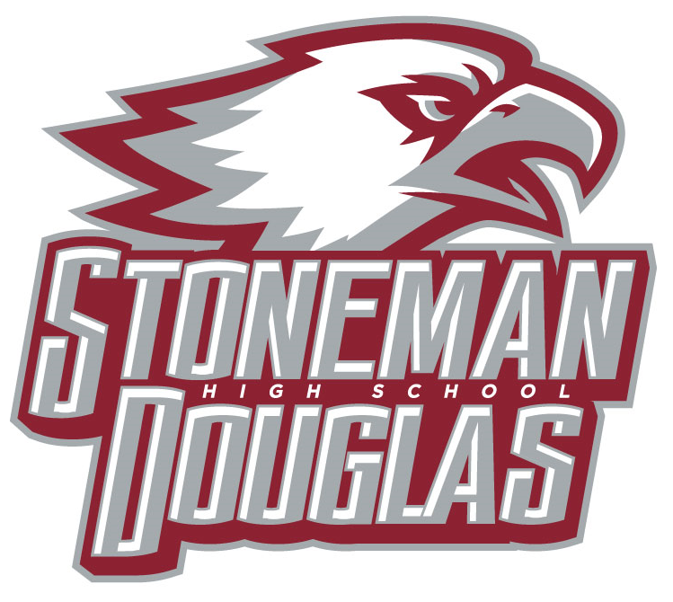

**Meeting Agenda**

**Date:** October 13, 2021

**Time:** 3:15 PM

**Location:** Media Center

1. Welcome/Call to Order/ Review of Agenda
2. Attendance (Roll call)
3. Principal’s Report
   1. SESIR update
4. Revision/Approval of Sept. 2021 SAC minutes
5. SAC Voting:
   1. SAC positions still needed for 2021-2022
      * 1. ESE
        2. ESOL
6. Meetings dates for 2021-2022

December 8th (waiver discussion)

January 12th (PSD waiver)

February 9th

March 9th (PSD continuation waiver vote and Customer survey)

April 13th (SPBP vote, create a nominating committee)

May 11th (Election for 2022-2023 officers)

1. Officers’ Report
   1. School Improvement Plan (SIP):Review SIP goals; Vote to Approve plan
   2. School-wide Positive Behavior Plan (SPBP): Monitoring; Passed by Faculty
   3. Accreditation Process: county is up for accreditation this year
   4. SAC School Accountability Funds: $78,466
      * 1. JSTOR- $3825 pending
2. Special orders/unfinished business from previous meeting
3. New business
4. Announcements/Reminder: Professional Study Days (PSD Thursdays students dismissed at 11:40 AM): 1 11/4, 12/2, 1/6, 2/3, 3/3, 4/7
5. Next meeting: December 8th at 3:15 PM
6. Adjournment